**Layered Approach to Value, EHS, Base**

1. **Value**
2. **ZEHS01N**
3. **Base**

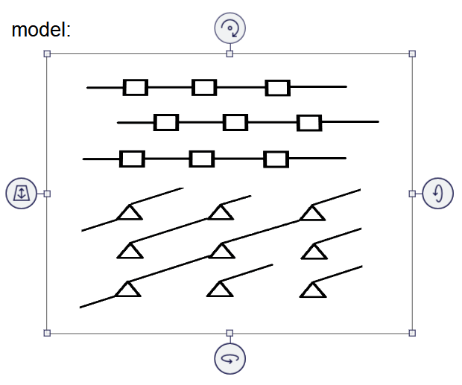

Base

ZEHS01N

Not Yet Added

Value

Occurrence of an Incident

IL : **C0000000000000000182**

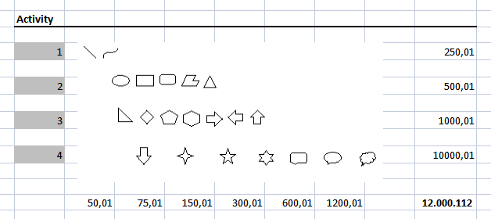

|  |  |  |  |  |  |  |
| --- | --- | --- | --- | --- | --- | --- |
|  | Payment | Document | Task | Data | Call | Cash |
| 1. Transport |  |  |  |  |  |  |
| 1. Sales |  |  |  |  |  |  |
| 1. Consumption |  |  |  |  |  |  |
| 1. Production |  |  |  |  |  |  |